BIF731 Final Term
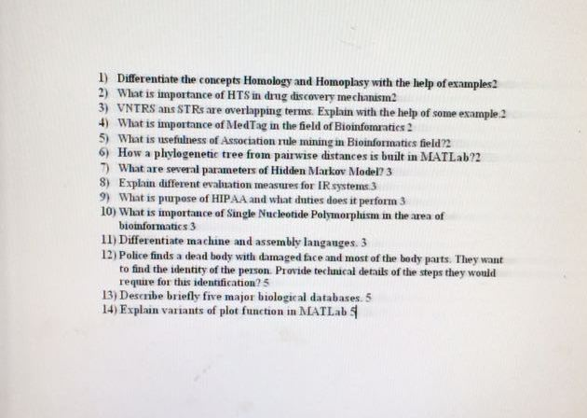
academic Research Paper Instructions

As part of your course grading, you are required to submit an academic research paper during the semester. This exercise is meant to inculcate in you the research temperament and skills by carrying out a deep study of any research topic/area relevant to this course. You may choose any topic, of your interest, relevant to the course. Following are the details of academic research paper: requirements, deadlines and marks.

Academic Research Paper Requirements:
Following are the requirements for the academic research paper:
a) Paper Length
Your paper should not be less than 6 pages and not more than 12 pages.
b) Quality of Writing
The clarity and style of expression, the degree to which your paper obeys the rules to formal academic grammar, punctuation, spelling, formatting details like paragraph indentation and location of page breaks, are part of quality of writing. Write and edit your paper carefully for good organization, clear language with good spelling, punctuation, etc.
c) Format
Your academic research paper must have these sections: Abstract, Introduction, Related Work, Analysis and Conclusion. You must have to follow format (especially of writing references in the text and at end of research paper under the title of ‘References’) as described by ‘Bioinformatics’ journal strictly. The format is available at this link under the heading of ‘Manuscript Preparation’. No academic research paper will be accepted without mentioned format.
d) References
You must have to study published research papers (minimum 15). The references of published research papers and books are allowed. Any unauthorized materials’ references will not be acceptable.

You can access Research Papers on your VULMS account using link [HEC Digital Library], Google Scholar and other online free research paper repositories (Some Journals of Bioinformatics: Nucleic Acid Research, Bioinformatics, BMC Bioinformatics, Current Bioinformatics, Evolutionary Bioinformatics etc.).

Submission and Deadlines
Students are required to finalize and submit their academic research paper by August 01, 2017.

As the academic research paper carries 15% of the total course grade, therefore it must contain implementation results of the proposed research idea. Similarly, in case of a review paper the “Discussion” section must contain student’s comments/conclusions and future research agenda regarding the domain being reviewed.

Team
Students may also take this assignment in group of two (02) members/students but in that case their academic research paper must be of high quality justifying the efforts of all the members in the group. Group information (VU IDs of group members) should be sent at course email address.

Warning: Write in your own words, do not copy-paste. Plagiarism is not acceptable. In case plagiarism is found, you will be awarded ZERO marks. No excuse will be accepted in this regard. For further understanding about plagiarism, please follow the links:

